EXPERIMENT-4
Dead Code Elimination Using Three Address Code in C
AIM:
To write a C program to identify and eliminate dead code from a given sequence of Three Address Code (TAC) statements.

PSEUDOCODE:
- Start.
- Read TAC statements until the user enters END.
- Identify the destination variable of each statement.
- Mark statements whose results are used by other live statements.
- Preserve final output assignments.
- Remove unused statements.
- Display the optimized TAC.
- Stop.

Program:
#include <stdio.h>
#include <string.h>

int main()
{
char code[100][100], lhs[100][20];
int live[100] = {0}, n = 0, i, j;
char line[100];

printf("Enter TAC (END to finish):\n");

while (fgets(line, sizeof(line), stdin))
{
line[strcspn(line, "\n")] = '\0';

if (strcmp(line, "END") == 0)
break;

if (strlen(line) == 0)
continue;

strcpy(code[n], line);
sscanf(line, "%19s", lhs[n]);
n++;
}

for (i = n - 1; i >= 0; i--)
{
if (strcmp(lhs[i], "x") == 0 ||
strcmp(lhs[i], "y") == 0)
live[i] = 1;

for (j = i + 1; j < n; j++)
{
if (live[j] && strstr(code[j], lhs[i]) != NULL)
live[i] = 1;
}
}

printf("\nOptimized Three Address Code:\n");

for (i = 0; i < n; i++)
if (live[i])
printf("%s\n", code[i]);

return 0;
}

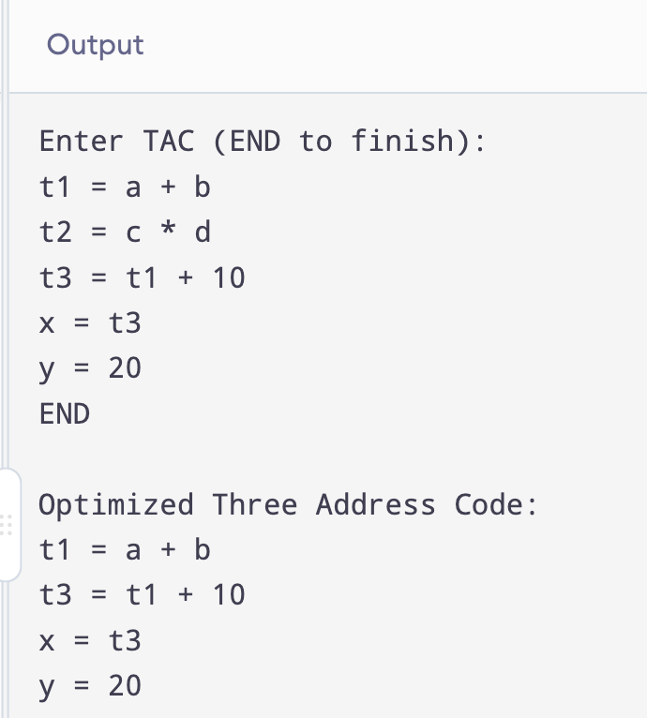
OUTPUT:

RESULT:

Thus, the C program to convert Three Address Code into target machine instructions was implemented and executed successfully.

